1) @relation dataset

@attribute a{true,false}

@attribute b{true,false}

@attribute c{true,false}

@attribute d{true,false}

@attribute e{true,false}

@data

true false false true true

true true true false true

true true false true true

true false true true true

false true true false true

false true false true true

false false true true false

true true true false false

true false false true true

true true false false true

**FP Growth:**

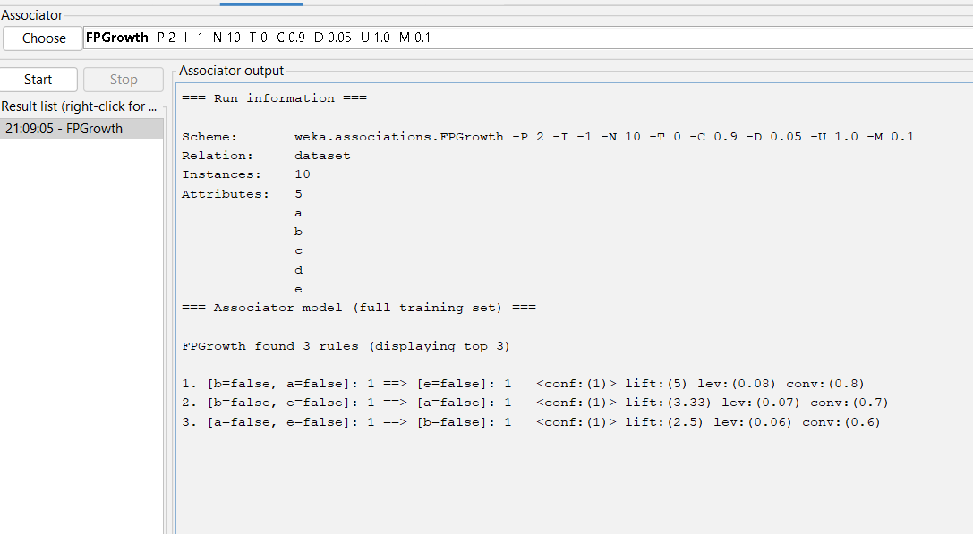

**Apriori:**

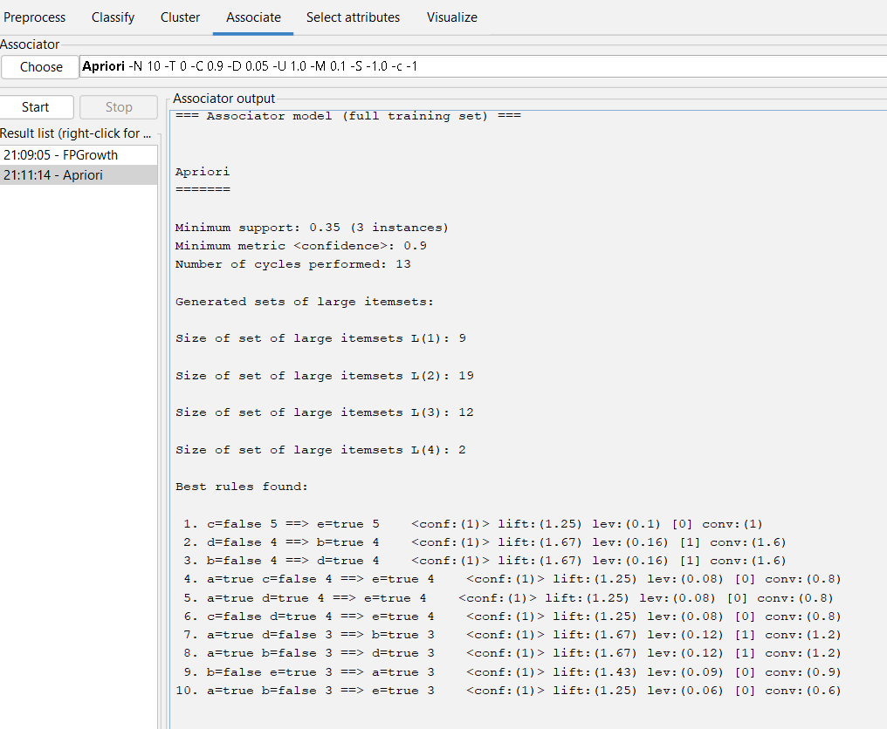

2)@relation dataset

@attribute Milk{true,false}

@attribute Beer{true,false}

@attribute Diapers{true,false}

@attribute Butter{true,false}

@attribute Bread{true,false}

@attribute Cookies{true,false}

@data

true true true false false false

true false false true true false

true false true false false true

false false false true true true

false true true false false true

true false true true true false

false false false true true true

false true true false false false

false true false false false true

**Apriori:**

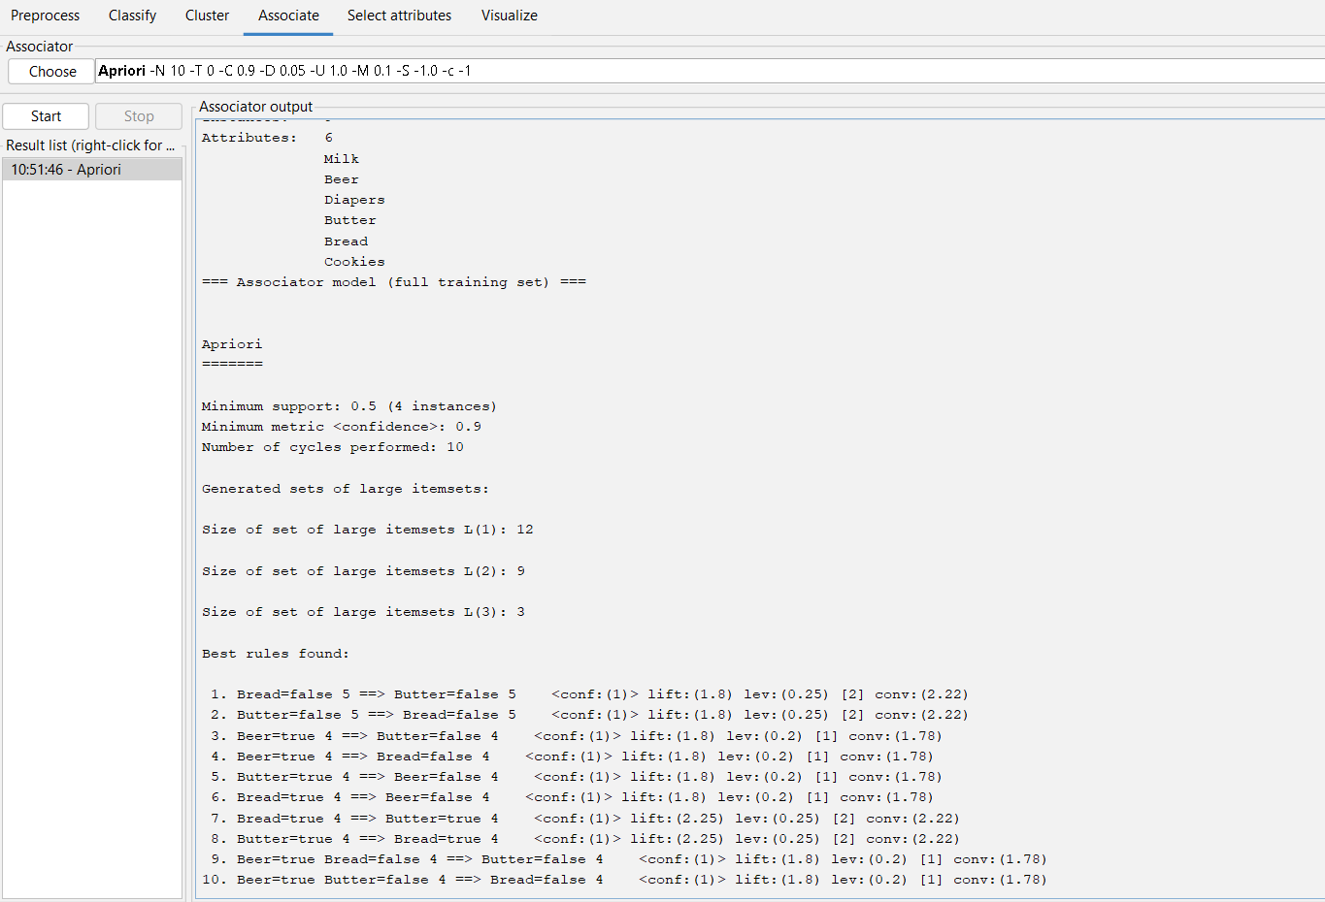

3) @relation decision_tree

@attribute age{young,middle,old}

@attribute income{low,medium,high}

@attribute student{yes,no}

@attribute Creit_rating{fair,excellent}

@attribute class{yes,no}

@data

young high no fair no

young high no excellent no

middle high no fair yes

old medium no fair yes

old low yes fair yes

old low yes excellent no

middle low yes excellent yes

young medium no fair no

young low yes fair yes

old medium yes fair yes

young medium yes excellent yes

middle medium no excellent yes

middle high yes fair yes

old medium no  excellent no

**Bayes classification:**

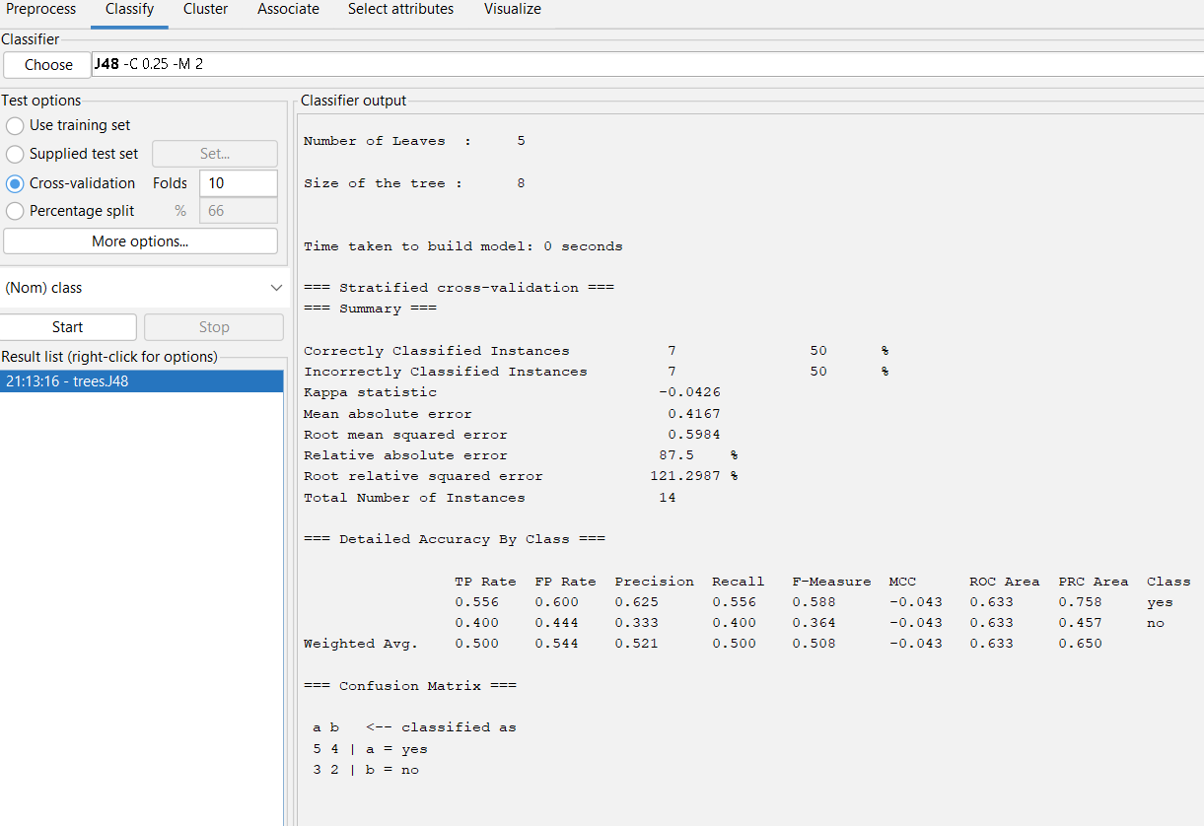

**decision tree:**

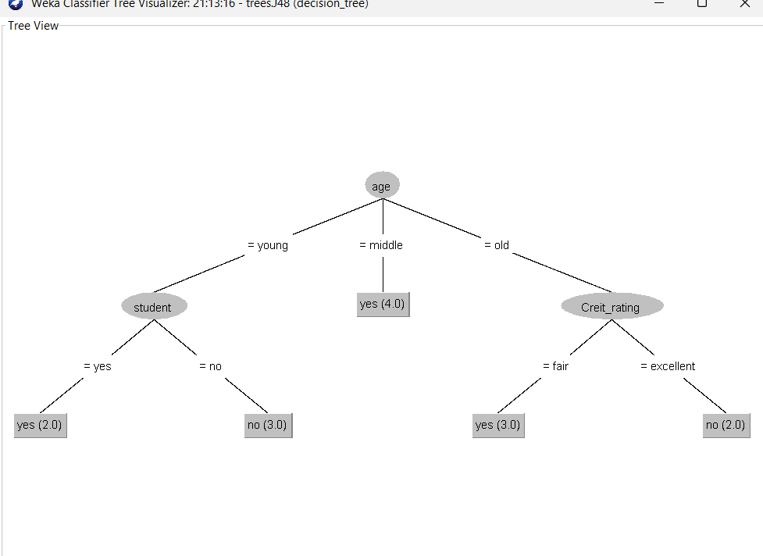

4) @relation dataset

@attribute M{true,false}

@attribute O{true,false}

@attribute N{true,false}

@attribute K{true,false}

@attribute E{true,false}

@attribute Y{true,false}

@attribute D{true,false}

@attribute A{true,false}

@attribute U{true,false}

@attribute C{true,false}

@attribute I{true,false}

@data

true true true true true true false false false false false

false true true true true true true false false false false

true false false true true false false true false false false

true false false true false true false false true true false

false true false true true false false false false true true

**Apriori:**

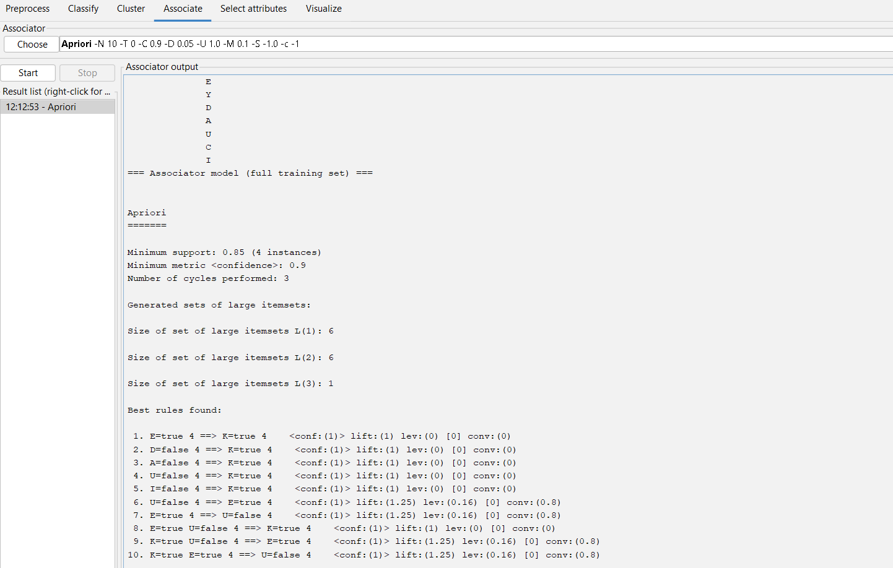

**FP Growth:**

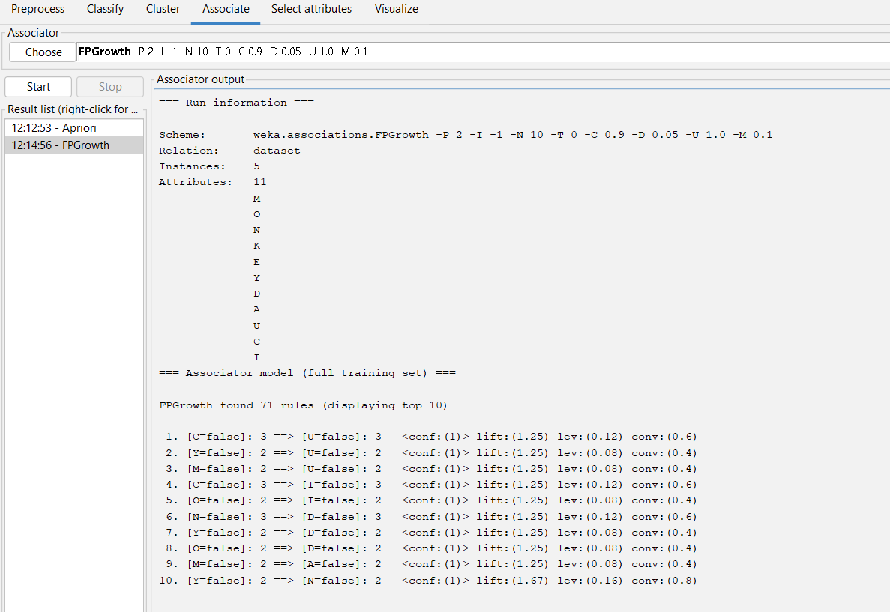

5) @relation hotdogs

@attribute hotdogs{t,f}

@attribute buns{t,f}

@attribute ketchup{t,f}

@attribute coke{t,f}

@attribute chips{t,f}

@data

t t t f f

t t f f f

t f f t t

f f f t t

f f t f t

t f f t t

output:

apriori algorithm:

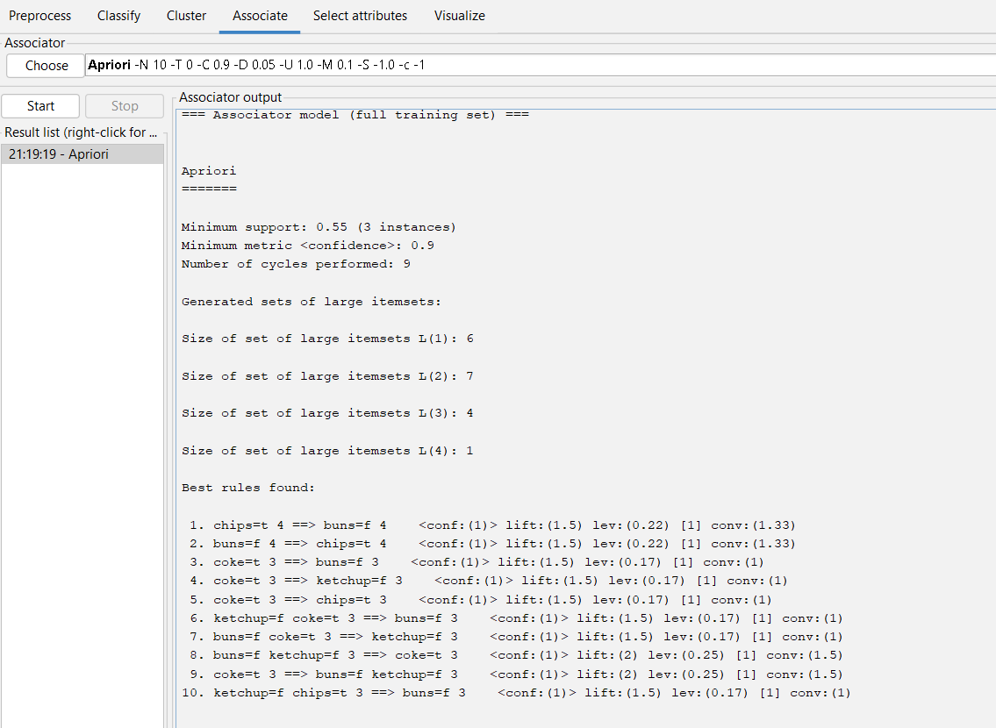

**FP Growth:**

